KWAME NKRUMAH UNIVERSITY OF SCIENCE & TECHNOLOGY, KUMASI
FACULTY OF ART
DEPARTMENT OF COMMUNICATION DESIGN

TITLE OF THESIS/DISSERTATION

by

FULL FIRST NAMES & SURNAME
e.g

Daniel Dzigbodi
Mariama Adbul
Kwabena Adu Koduah
Esther Lilly Mills-Quinn

Bachelor of Art (Communication Design)

Date submitted (e.g. September 2023)

KWAME NKRUMAH UNIVERSITY OF SCIENCE & TECHNOLOGY, KUMASI
FACULTY OF ART
DEPARTMENT OF COMMUNICATION DESIGN

TITLE OF THESIS/DISSERTATION

by

FULL FIRST NAMES & SURNAME
e.g

Daniel Dzigbodi
Mariama Adbul
Kwabena Adu Koduah
Esther Lilly Mills-Quinn

Thesis/Project (choose the correct one) submitted in fulfilment/partial fulfilment (choose the correct one) of the requirements for the degree Bachelor of Art (Communication Design)

Date submitted (e.g. September 2023)

DECLARATION

I hereby declare that this submission is my own work towards the BA Communication Design and that, to the best of my knowledge, it contains no material previously submitted by another person, nor material which has been accepted for the award of any other degree of this or any other university, except where due acknowledgement has been made in the text.

…………………………………………..
Student Name & Index No.

……………………………………………
Signed

……………………………………………
Date

Certified by:

…………………………………………..
Supervisor name

……………………………………………
Signed

……………………………………………
Date

Certified by:

…………………………………………..
Head of Department Name

……………………………………………
Signed

……………………………………………
Date

DEDICATION

This is optional, and may be omitted.

For (whomever)

TABLE OF CONTENTS

If you are an accomplished user of Microsoft Word, you can type your thesis using STYLES, and generate an automatic Table of Contents. If not, use the template below. This gives you an indication of section and sub-section numbering. Do the Table of Contents right at the end, otherwise you will have to update it continuously. If you are typing each chapter in a separate file, you might find it easier to collate the final thesis if you number your pages according to each chapter, e.g., in Chapter 3, your page numbers will be 3-1, 3-2, 3-3, etc. In Chapter 4 your page numbers will be 4-1, 4-2, 4-3, 4-4, etc.

Make sure that your headings are exactly the same as those in the text (use of sentence case and title case also). Sentence case is less confusing, easier to use and looks more modern and professional. Align page numbers on the right. Use single line-spacing.

DECLARATION  ACKNOWLEDGEMENTS  DEDICATION  GLOSSARY | ii
 | iv
 | v
 | viii

LIST OF TABLES (these are numbered according to the chapter in which they appear)
Table 1.1: Caption | 75
Table 3.1: Caption | 82
Table 4.1: Caption | 101

LIST OF FIGURES (Illustrations/charts used. These are numbered according to the chapter in which they appear)

Figure 4.1: Caption
Figure 4.2: Caption
Figure 5.1: Caption

LIST OF PLATES (Pictures/Images used. These are numbered according to the chapter in which they appear)
Plate 4.1: Caption | 75
Plate 4.2: Caption | 82
Plate 5.1: Caption | 101

CHAPTER ONE: INTRODUCTION
  - Background to the study 1
  - Statement of the problem 4
  - Research questions 5
  - Objectives 6
  - Importance of the study 7
  - Limitations (If no limitation, delete this) 8

CHAPTER TWO: REVIEW OF RELATED LITERATURE
2.0 Overview
  - Title for the review 9
    - Title for the review 10
    - Title for the review 11
    - Title for the review 12
    - Title for the review 13

CHAPTER THREE: METHODOLOGY
  - Research design 14
  - Population 14
  - Sampling 14
  - Data collection procedure 14
  - Data collection tools 14
  - Facilities available

CHAPTER FOUR: PRESENTATION OF DATA AND DISCUSSIONS
  - Project execution/Presentation of data 14
  - Analysis of data 14
  - Interpretation of data 14

CHAPTER FIVE: SUMMARY, CONCLUSIONS, AND RECOMMENDATIONS
    - Summary 14
    - Conclusions 14
    - Recommendations 14

REFERENCES (Use Harvard style reference in alphabetical order) | 65

APPENDICES (If available) | 66

APPENDIX/APPENDICES  (Choose one. If you have only one appendix, don’t use Appendix A. List it as simply as Appendix.) | 160
Appendix A: Caption | 161
Appendix B: Caption | 163

Add C, D, E, etc.

CHAPTER ONE

INTRODUCTION

  - Background to the study
Ensure that Ms Word is set and defaulted to English (UK). Your margins should be 4cm (left) (as this allows for binding) and 2.5cm (right, top and bottom). Type your dissertation/thesis in 2-line spacing, 12-point, for all chapters. (Items in the Bibliography, as well as information typed inside tables, are typed in single-line spacing.) Use one space after all punctuation marks. Use decimal subdivisions as indicated below. Note the use of the HARVARD style of bibliographic citation. Footnotes should be used sparingly (use Microsoft Word: Insert – Reference – Footnote), mainly to clarify concepts or add information which does not pertain directly to the text. Note the justified right-hand margin in the text.

NB. Do not justify right tables or the Bibliography/References, as this will give you unnecessary white space. Press enter twice to move to the next paragraph.

1.2
1.3
1.4
1.4.1
1.4.2
1.4.3
1.4.3.1
- Bullet (single spacing)
- Bullet
- Bullet

CHAPTER TWO

REVIEW OF RELATED LITERATURE

2.0 Overview
Ensure that MS Word is set and defaulted to English (UK).

2.1 Review title
Lorem ipsum dolor sit amet, consectetuer adipiscing elit. Maecenas porttitor congue massa. Fusce posuere, magna sed pulvinar ultricies, purus lectus malesuada libero, sit amet commodo magna eros quis urna. Nunc viverra imperdiet enim. Fusce est. Vivamus a tellus.
Pellentesque habitant morbi tristique senectus et netus et malesuada fames ac turpis egestas. Proin pharetra nonummy pede. Mauris et orci. Aenean nec lorem. In porttitor. Donec laoreet nonummy augue.
Suspendisse dui purus, scelerisque at, vulputate vitae, pretium mattis, nunc. Mauris eget neque at sem venenatis eleifend. Ut nonummy. Fusce aliquet pede non pede. Suspendisse dapibus lorem pellentesque magna. Integer nulla.

  - Review title
Lorem ipsum dolor sit amet, consectetuer adipiscing elit. Maecenas porttitor congue massa. Fusce posuere, magna sed pulvinar ultricies, purus lectus malesuada libero, sit amet commodo magna eros quis urna. Nunc viverra imperdiet enim. Fusce est. Vivamus a tellus.
Pellentesque habitant morbi tristique senectus et netus et malesuada fames ac turpis egestas. Proin pharetra nonummy pede. Mauris et orci. Aenean nec lorem. In porttitor. Donec laoreet nonummy augue. Suspendisse dui purus, scelerisque at, vulputate vitae, pretium mattis, nunc. Mauris eget neque at sem venenatis eleifend. Ut nonummy. Fusce aliquet pede non pede. Suspendisse dapibus lorem pellentesque magna. Integer nulla.

Figures comprise diagrams, graphs, bar charts, pie charts, etc. They are all termed “Figures”, and are captioned below the figure (Microsoft Word: Insert – Reference – Caption). If the caption is longer than one line, it should be typed in single line-spacing. Figures taken (or adapted) from a source should be acknowledged as in the example below, and should appear in the Bibliography/References. Leave at least two spaces (press enter twice) above and below a figure, to separate it from the text. Photographs or pictures that have been presented in the study should rather be captioned as “Plate”.

Figure 1.1: Add caption below the figure (10-point bold)
Use single-line spacing and sentence case with no full stop
Centre, or align left

(Adapted from Bloggs, 1999:34)

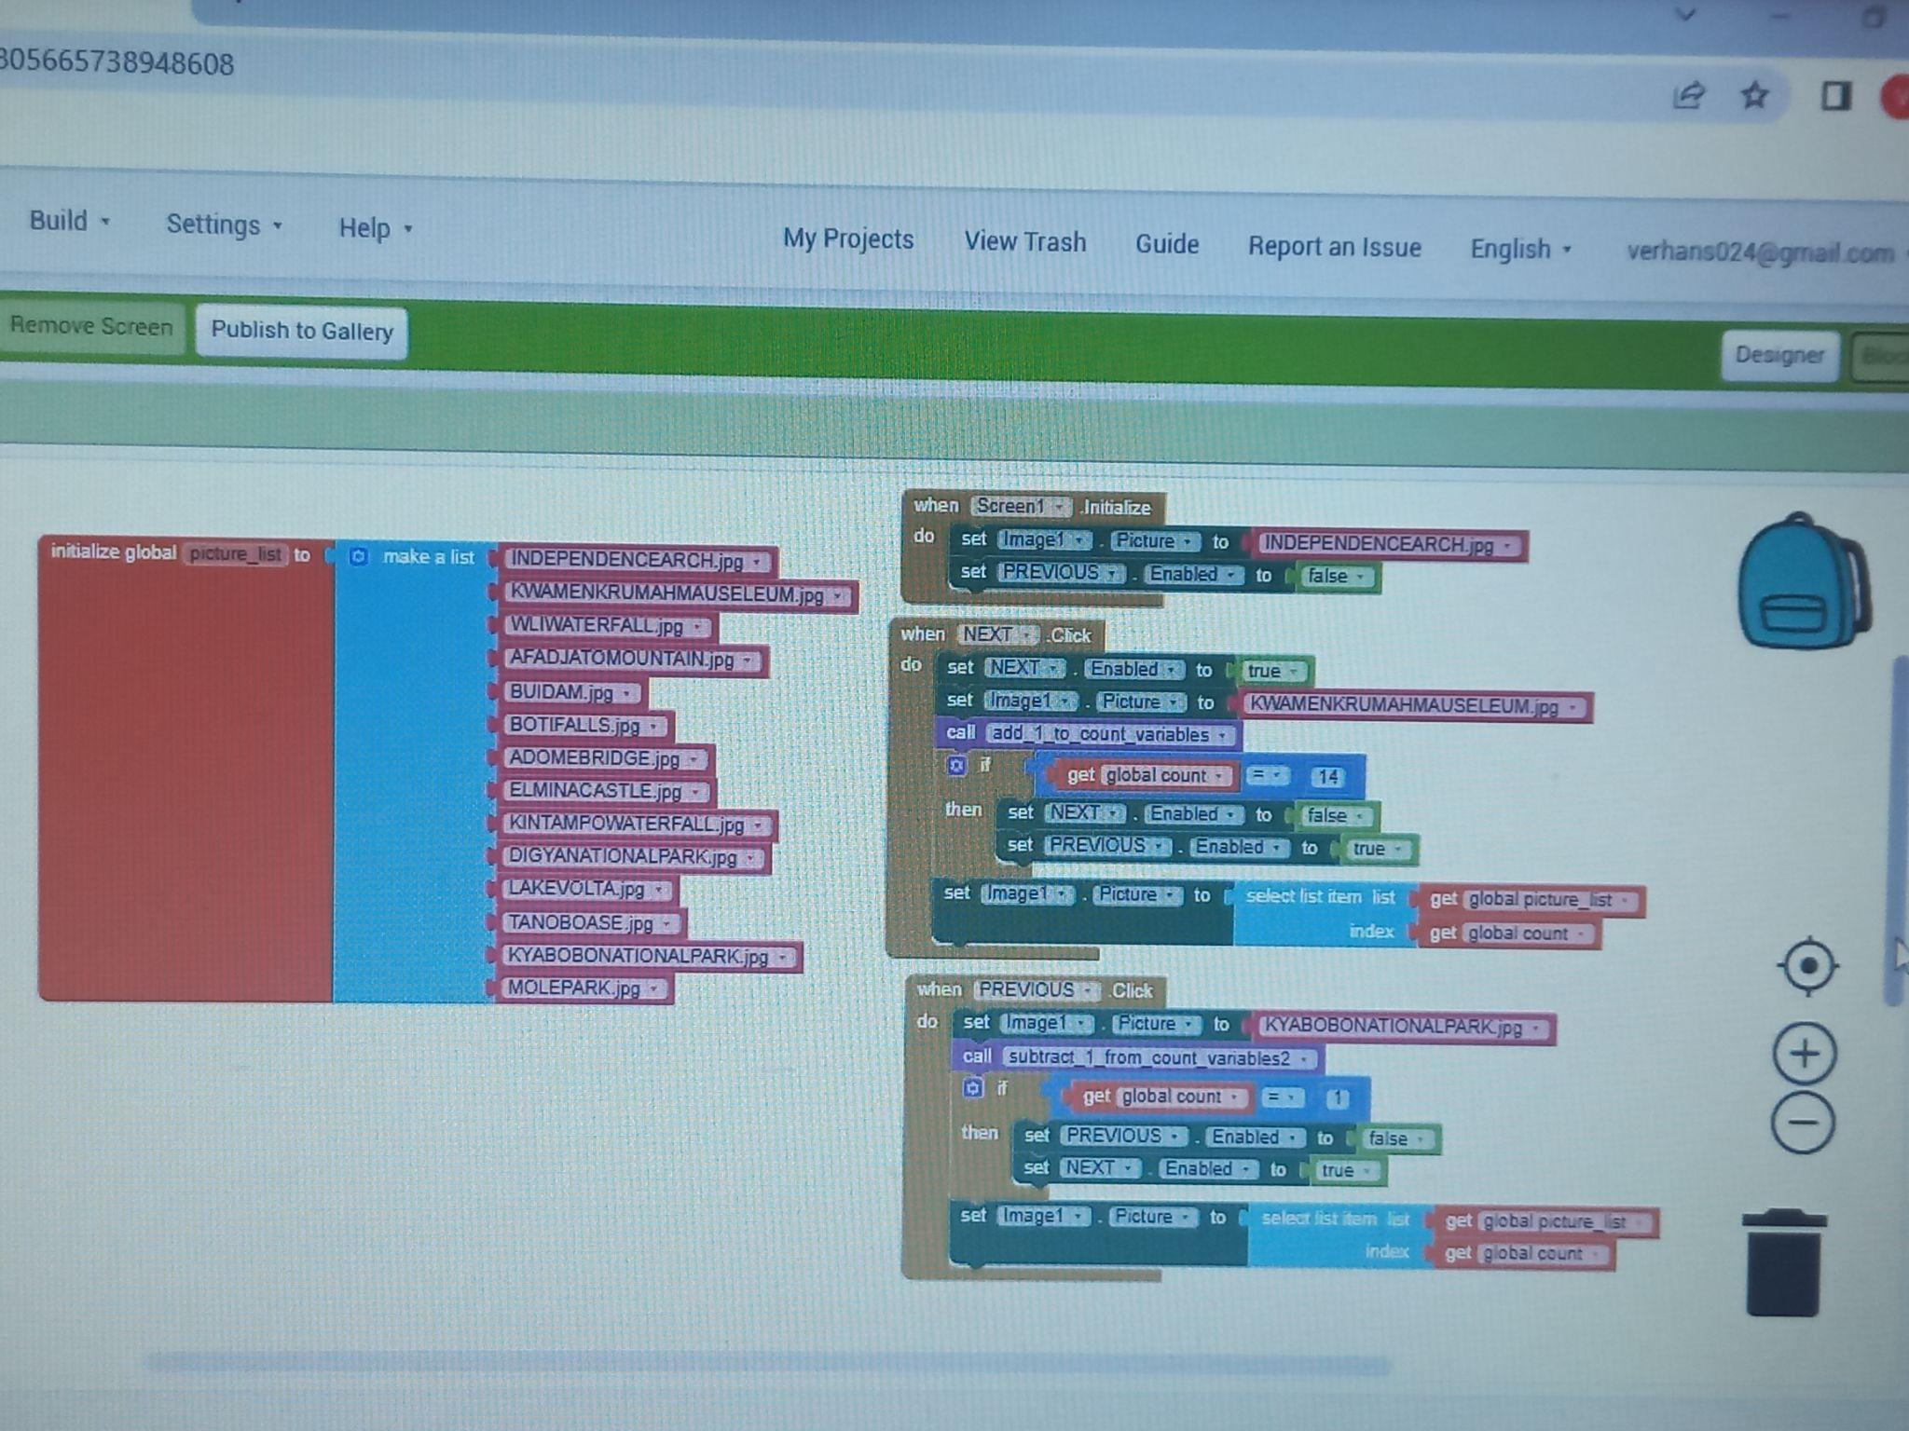
Plate 1.1: Add caption below the figure (10-point bold)
Use single-line spacing and sentence case with no full stop
Centre, or align left

Tables comprise text and figures in tabular form. Tables are typed in single line-spacing, with left justification. Figures should be aligned to the right, as in the example below. If you have a great deal of text, use a smaller (but legible) font, e.g. 9- or 10-point. Acknowledge tables taken from another source as for figures, above. Leave at least two spaces (press enter twice) above and below a table, to separate it from the text.

Table 1.1: Add caption above the table (10-point bold), single-line spacing, sentence case, and no full stop
Heading | Heading | Heading | Heading | Rands
Remember to justify left and use single spacing. Check your punctuation at the end and be consistent. | Use a smaller font if you have a great deal of text. This is 9-point Arial. | Eight-point is generally too small to be read comfortably. | Use right justification for figures, as in the next table. Remember to right align the caption, also. | 1 234  130  18 987  120 764  123
Text of tables should not “overflow” onto the next page, but should be enclosed in a new row and column. | Very wide tables should be “landscaped” – remember to use a wide-enough margin for binding.

* Please use your detailed information to complete the Chapters above and als use them as guide to complete the remaining chapters

BIBLIOGRAPHY/REFERENCES
Type your References (only sources cited), preferably in a table using invisible gridlines. This enables you to sort alphabetically, using Microsoft Word: Table – Sort. Use single-line spacing, with one line space between items. The examples below cover most types of documents you will encounter. Pay careful attention to spacing (one space after all punctuation marks) and to the use of title case and sentence case in titles of books, sub-titles of books, journal articles, and journal titles. Do not justify the right margin.

Brunner, H. (1972). Hieroglyphic writing: the Egyptian legacy. 3rd ed. New York: Simon & Schuster.

Chase, J. 1979. Advertising in the modern world: an international survey. Englewood Cliffs, NJ: Prentice-Hall.
Ellis, R. & Peters, J.P. (2000). Writing about literature. London: Macmillan.

Gardner, B.P. & Smith, G. (eds). (1984). Child psychology: an introductory guide for parents and teachers. Harmondsworth: Penguin.

Henderson, R.S., Smith, P.G., Rossiter, I. & King, P.Q. (1987). The tenets of moral philosophy. New York: Van Nostrand.

Pringle, G.S. (1982a). Aspects of style in the novels of J.M. Coetzee. College English, 35(6): 34-41.

Pringle, G.S. (1982b). The novels of J.M. Coetzee. Unpublished PhD thesis, Rhodes University, Grahamstown.

Puttnam, R.A. (1981). The place of values in a world of facts. In Duff, A. & Smithson, W.O. (eds). The nature of the physical universe. Oxford: Oxford University Press: 45-54.

Shuttleworth, M. (2004). Interview with the researcher on 4 August 2004.

South Africa. (1982). Atomic Energy Act, No. 92 of 1982. Pretoria: Government Printer.

South Africa. Department of Education. (1995). A qualification structure for universities in South Africa: Report 116. http://www.education.gov [25 October 2007].

Stewart, M.T. (1988). Should privatisation prosper? SAA in the year 1990. Cape Argus: 3, May 17.

Truter, M. (1995). The role of the court interpreter in the new South Africa. Tower of Babel or Lingua Franca? Proceedings of the 1994 Conference of the Design, Development, Research, Kumasi, Ghana, 18-23 June 2013. KNUST; 56-67. [ISBN:9-987-3245-0]

Van Aswegen, L. (2007). Library research and the Harvard method of bibliographic citation: a research writing and style guide for postgraduate students. Kumasi: KNUST.

APPENDIX/APPENDICES

If you have only one appendix, caption it Appendix.
If you have more than one (note the plural appendices), caption them Appendices, and list them as Appendix A, Appendix B, etc.

APPENDIX A: TITLE

APPENDIX B: TITLE

<< This document was last edited in April 2023 >>>

